Telluride Conference on Epithelial Physiology and Cell Biology
Organizers: Tom Kleyman, My Helms, Pete Snyder
Telluride Elementary School (TSRC)
447 W Columbia Ave
____________________________________________________________________________

Monday July 25, 2016
12:30-1:20 PM My Helms
1:20-2:10 PM Rebecca Hughey
2:10-2:40 PM Break-refreshments
2:40-3:10 PM Jonathan Nizar
3:10-4:00 PM Abdel Alli
4:00-4:10 PM Break-refreshments
4:10-5:00 PM Arohan Subramanya

Tuesday July 26, 2016
7:30 AM Breakfast at TSRC
8:00-8:50 AM Alexander Staruschenko
8:50-9:40 AM Pablo Ortiz
9:40-10:10 AM Break-refreshments
10:10-10:40 AM Cary Boyd-Shiwarski
10:40-11:30 AM Doug Eaton
11:30-11:40 AM Break-refreshments
11:40-12:30 PM Carolyn Ecelbarger

12:30-1:30 PM Lunch (on own)

1:30-2:20 PM Jeff Garvin
2:20-3:10 PM Daniela Rotin
3:10-3:40 PM Break-refreshments
3:40-4:30 PM David Pearce

6:00-7:00 PM Town talk
Telluride Conference Center in
Mountain Village
“The Salty Sea Within Us"
Tom Kleyman
(cash bar at 5:30)

Wednesday July 27, 2016
7:30 AM Breakfast at TSRC
Group Science Hike

6:00 – 9:00 PM Picnic

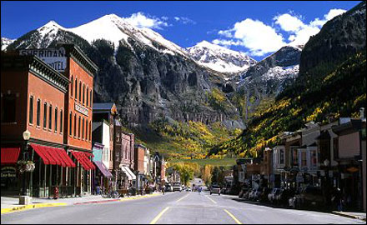

Thursday July 28, 2016
12:30-1:20 PM Tom Kleyman
1:20-2:10 PM Olivier Staub
2:10-2:40 PM Break-refreshments
2:40-3:10 PM Amity Eaton
3:10-4:00 PM James McCormick
4:00-4:10 PM Break-refreshments
4:10-5:00 PM Oleg Palygin

Friday July 29, 2016
7:30 AM Breakfast at TSRC
8:00-8:50 AM Vivek Bhalla
8:50-9:40 AM Shujie Shi
9:40-10:10 AM Evan Ray
10:10-10:25 AM Break-refreshments
10:25--11:15 AM Chuck Downs
11:15-12:05 PM Pete Snyder

